Celebrating Success!
Senior Care of Marion
• January of 2020 •
Reliant Rehabilitation • Care Matters
Senior Care of Marion would like to celebrate the success of a very special individual,
Mr. Scott Clapet.

Mr. Clapet came to SCOM at the beginning of November. He has made great gains while he has been here. Upon admission he could not get himself in or out of bed, nor could he walk without assistance. Mr. Clapet is now able to dress himself, feed himself, take himself to the bathroom and ambulate greater than 200ft using his rolling walker. We are so proud of his hard work. Upon discharge he will be joining his family in another state. We wish him much luck!

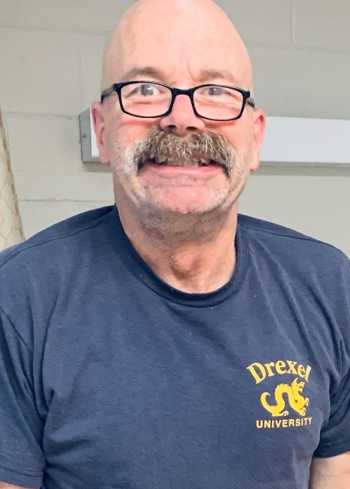
MODEL 10 FUNCTIONAL OUTCOME SUMMARY
Functional Area |  |  |  |  |  |  |  | Admission Level |  |  |  | OLFI* |  | 30 Days | Percent of OLFI
ADLs |  |  |  |  |  |  |  |  | 3.3 |  |  | 5.7 |  | 6.3 |  | 110%
Balance |  |  |  |  |  |  |  |  | 3 |  |  | 7.5 |  | 8.5 |  | 113%
Functional mobility  Cognitive Level |  |  |  |  |  |  |  |  | 3.2 |  |  | 6.3 |  | 6.6 |  | 104%
 |  |  |  |  |  |  |  |  | 3 |  |  | 8 |  | 9 |  | 112%
Patient achieved 88.4% of their optimal level of independence.

Facility Name: Senior Care of Marion
Address: 2770 US 501
Phone: (855) 573-8466
Name of Rehab Director: Laura Trussell
Name of Administrator: Lynn Gibbs

